PIZZA SALES ANALYSIS
USING MYSQL
1. Total Revenue
SELECT
SUM(total_price) AS total_revenue
FROM
pizza_sales
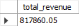

2. Total Quantity Sold per Pizza Category.
SELECT
pizza_category, SUM(quantity) AS total_quantity
FROM
pizza_sales
GROUP BY pizza_category
ORDER BY total_quantity DESC
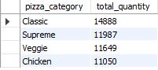

3. Total Revenue per Pizza Size
SELECT
pizza_size, SUM(total_price) AS total_revenue
FROM
pizza_sales
GROUP BY pizza_size
ORDER BY total_revenue DESC
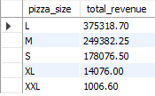

4. Top-Selling Pizza (by Quantity)
SELECT
pizza_name, SUM(quantity) AS total_quantity
FROM
pizza_sales
GROUP BY pizza_name
ORDER BY total_quantity DESC
LIMIT 1


5. Top 5 Pizzas by Revenue
SELECT
pizza_name, SUM(total_price) AS total_revenue
FROM
pizza_sales
GROUP BY pizza_name
ORDER BY total_revenue DESC
LIMIT 5
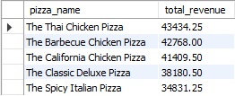
6. Daily Sales Revenue
SELECT
order_date, SUM(total_price) AS total_revenue
FROM
pizza_sales
GROUP BY order_date
ORDER BY order_date
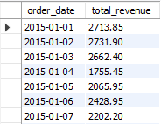

7. Average Order Value (AOV)
SELECT
ROUND(SUM(total_price) / COUNT(DISTINCT order_id),
2) AS average_order_value
FROM
pizza_sales
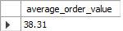

8. Monthly Revenue
SELECT
YEAR(order_date) AS year,
MONTH(order_date) AS month,
SUM(total_price) AS monthly_revenue
FROM
pizza_sales
GROUP BY YEAR(order_date) , MONTH(order_date)
ORDER BY year , month
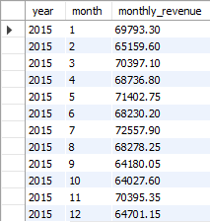

9. Highest Revenue Pizza in Each Category
select pizza_category, pizza_name, heighest_revenue
from(
select pizza_category, pizza_name,
sum(total_price) as heighest_revenue,
rank() over(partition by pizza_category order by sum(total_price) desc) as m
from pizza_sales
group by pizza_category, pizza_name
) as t
where m = 1
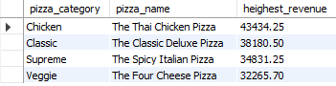

10. Category-Wise Revenue Contribution (%)
with total as
(select sum(total_price) as total_revenue
from pizza_sales)
select pizza_category,
sum(total_price) as category_revenue,
(sum(total_price)/(select total_revenue from total)) * 100 as revenue_percentage
from pizza_sales
group by pizza_category
